Build framework using <https://nodemcu-build.com/> service

Flashing esp8266 with ESP8266Flasher.exe tool

Configuration for esp8266-01

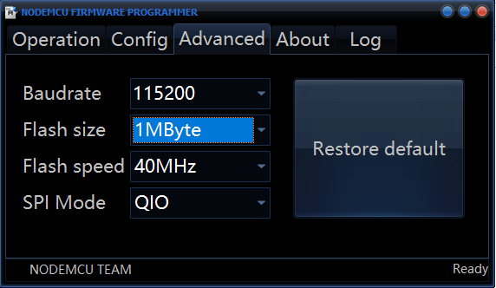

Configuration for esp8266-12 or esp8266-01

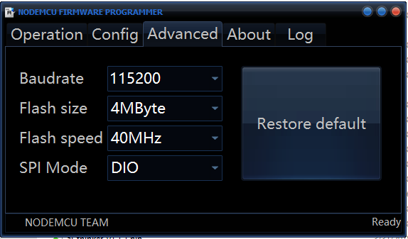

User ESPlorer application to connect to esp8266 and upload files to in